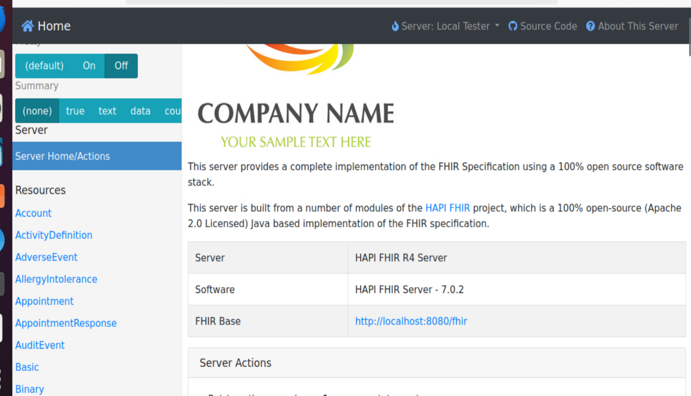

2. free -h

3. nc -zv 192.168.17.54 8080

4. netstat -tuln | grep 8080

**Bonus**

**5.**

